Coimbatore Institute of Technology

Department of AI and DS

Home Appliance Control System
Software Requirements Specification

Version: 1.0d

Document Id:
Author(s): 1.R J Rajivathini
2.H Rajeshwari
3.S Dharshini
4.G Shangara Vadivel
5.S Arivuselvan
Date:24-08-2025

Modification History

Date | Modifications | Reason | Version
1/7/2025 | Create a draft version of the document. | Adapted from various IEEE standards on software requirements specification | 0.7d
15/7/2025 | Add guidelines and faked examples as italics. | For students to follow | 0.8d
1/8/2025 | Minor amendments | As recommended by reviewer | 0.9d
14/8/2025 | Modify document content for the HACS | Adapted for Assignment 1 of Semester 2 | 1.0d
…
Table 1.0 Modification History

Contents

1 Introduction 6
1.1 Document Purpose 6
1.2 About the Project 6
1.3 Document Scope 6
1.4 Terminology Used 6
1.5 Related Documents 7
1.6 Document Overview 7
2 Product Overview 7
2.1 Introduction 7
2.2 Business Services Supported 7
2.3 Product Characteristics 8
2.4 User Characteristics 8
2.5 General Constraints 9
2.6 Priority of requirements 9
3 Functional Requirements 9
3.1 HACS Authentication System 10
3.2 HACS Appliance Controller list 12
4. User Interface Requirements 13
4.1 Look and Feel Requirements 13
4.2 Usability Requirements 13
5. Non-Functional requirements 13
5.1 Performance requirements 13
5.2 Reliability requirements 14
5.3 Security requirements 14
5.4 Maintainability requirements 14
5.5 Other non-functional requirements … (Students to complete) 14
5.6 … (Students to complete) 14
6. Operating Environment 14
6.1 Hardware 14
6.2 Software 14
6.3 Printer 14
6.4 External Data Storage 14
7. Acceptance Criteria 15
References 15
Glossary 15
Index 16
Purpose of Appendices 16
Appendix A: External Context Model 17
Appendix B: Internal Context Model 17
Appendix C: Use Case Analysis Notes 17
Appendix D: Development Process 17
Appendix E: Contributions 18
Appendix F: Meeting Agendas/Minutes 19
Appendix G: Problem Investigation Reports 19

1 Introduction
The Home Appliance Control System (HACS), developed for the 23AD313 Software Engineering Principles and Practices coursework, enables remote monitoring and control of appliances for convenient and efficient household management. This document outlines functional and non-functional requirements along with system constraints, serving as the primary output of the Requirements Elicitation Phase. It establishes a clear baseline for both instructors (clients) and the student team (developers), forming the foundation for system design, implementation, and testing.

1.2 About the Project

The aim of this project is to perform Requirements Elicitation and Specification for the Home Appliance Control System (HACS), focusing on identifying, analyzing, and documenting requirements as per the 23AD313 Software Engineering Principles and Practices course. The scope is limited to elicitation and documentation of requirements, while later phases like design, implementation, and testing will be addressed in future work.

1.3 Document Scope

This document defines the requirements for the Home Appliance Control System (HACS), covering functional/non-functional requirements, features, use cases, actors, and constraints. It focuses solely on the requirements elicitation and specification phase, excluding design, coding, deployment, and maintenance.

1.4 Terminology Used

Term/Acronym | Definition/Description
Developers | The team responsible for the complete development of the Home Appliance Control System (HACS).
Process | The set of activities followed by students to complete the requirements elicitation, documentation, and submission for the assignment.

Requirement | A condition or capability needed by a user to solve a problem or achieve an objective within HACS.
Specification | A document that prescribes, in a complete, precise, and verifiable manner, the requirements, design, behaviours, or other characteristics of a system or its components.
User | The person operating and/or using the HACS system through devices like mobile, desktop, or palm-top.
HACS | Home Appliance Control System – a system that enables remote control, monitoring, and coordination of appliances such as microwave oven, sprinklers, pet feeder, etc.
Session | A valid communication link established between the remote device and the HACS Appliance Controller after authentication.
System Administrator | The authorized person responsible for managing users, adding/modifying appliances, and overseeing system operations.

1.5 Related Documents
The following documents and resources have been referred to in preparing this Software Requirements Specification (SRS) for the Home Appliance Control System (HACS):
- Assignment Brief – Requirement Elicitation and Documentation: Home Appliance Control System (HACS), Department of AI and DS, Course Code: 23AD313.
- Document Standards – Provided by the Department of AI and DS for formatting and structuring the SRS.
- Software Engineering Principles and Practices Course Material – Lecture notes and reference slides related to requirements elicitation, use case modelling, and specification.
- IEEE SRS Template (IEEE 830-1998 Standard) – Used as a reference framework for preparing this document.

1.6 Document Overview
This document is organized into multiple sections to clearly define the requirements of the Home Appliance Control System (HACS).
- Section 1: Introduction – Provides the purpose, scope, terminology, related documents, and overview of this SRS.
- Section 2: System Context – Identifies system actors, describes interactions, and presents the context diagram.
- Section 3: Use Case Modeling – Details the use case diagram, textual descriptions of use cases, exceptions, and variations.
- Section 4: Functional Requirements – Specifies the core functions grouped by use cases (e.g., microwave, sprinkler, pet feeder, etc.).
- Section 5: Non-Functional Requirements – Defines performance, security, usability, adaptability, and reliability requirements.
- Section 6: Administrative Features – Requirements related to system administrator activities such as adding/deleting appliances or users.
- Section 7: Appendices – Contains supporting materials like glossary, references, and diagrams.

2 Product Overview
The Home Appliance Control System (HACS) enables users to remotely monitor and control appliances such as microwaves, sprinklers, security systems, entertainment devices, air conditioning, and pet feeders. It is accessible through smartphones, desktops, and tablets using the Internet or WAP, offering secure login, real-time status, and user-friendly controls. Examples include turning on sprinklers, scheduling a pet feeder, or preheating a microwave before arriving home. Designed for flexibility and scalability, HACS supports the easy addition of new appliances. It ensures reliable and secure communication for efficient household management.
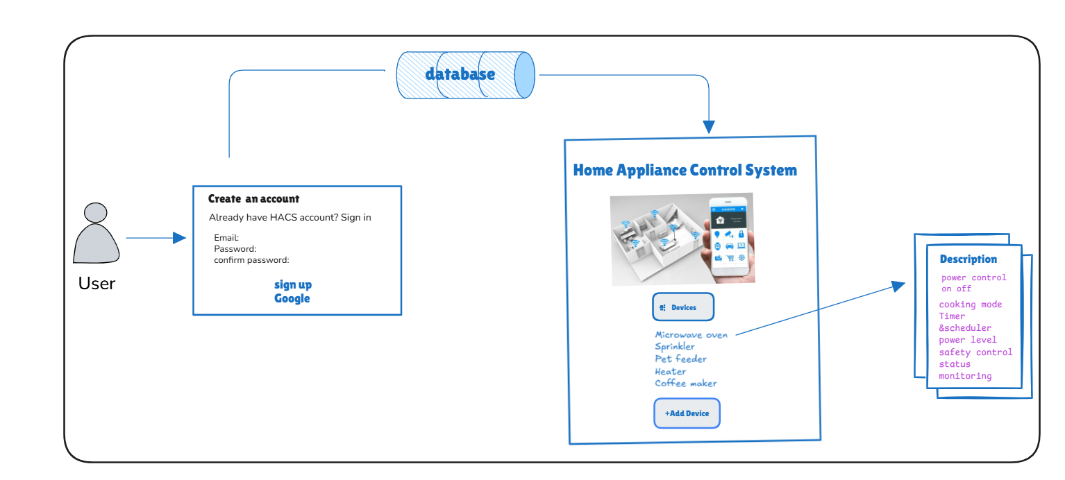

2.2 Business Services Supported
The Home Appliance Control System (HACS) shall provide software support for the following key operations:
- User Authentication – Validate users through login credentials before granting access to the system.
- Session Management – Establish and maintain a valid communication session between the remote device and the HACS Appliance Controller.
- Appliance List Display – Provide the user with a list of all available appliances that can be accessed and controlled.
- Appliance Status Monitoring – Allow users to view the current state of an appliance (e.g., ON/OFF, scheduled, running time, etc.).
- Appliance Control Operations – Enable users to perform operations such as switching appliances ON/OFF, adjusting settings, or scheduling activities.
2.3 Product Characteristics
HACS enables remote appliance monitoring and control via smartphones, desktops, and tablets with secure login, real-time status, and user-friendly controls. It is scalable, reliable, and supports easy integration of new devices.
2.3.1 User Interface
The system provides intuitive GUIs across platforms with login screens, appliance menus, control panels (e.g., microwave, sprinkler, pet feeder), and dashboards for real-time status. Design ensures clarity, responsiveness, and easy navigation.
2.3.2 Operating Environment
HACS runs on PCs (min. Pentium 800 MHz, 256 MB RAM, 150 MB disk, Windows 2000) and is platform-independent via JVM, supporting Windows, Linux, and macOS for flexibility.
2.3.3 Hardware Interfaces
Interfaces include a USB module for appliance controller connection, appliance control modules, handheld wireless controller for redundancy, network interface (Wi-Fi/Ethernet) for connectivity, and optional sensor inputs for automation.
2.4 User Characteristics
HACS will be used by homeowners, family members, administrators, and occasionally service technicians. Homeowners and residents need only basic smartphone/computer skills to log in, navigate menus, and control appliances. Administrators require moderate technical knowledge for configuration, networking, troubleshooting, and security management. Service technicians may assist with maintenance or upgrades, requiring strong technical expertise.
2.4.1 General User Characteristics
Users should be able to read English, operate smartphones/PCs, understand household appliances, and follow on-screen instructions. A willingness to use a simple graphical interface is expected.
2.4.2 Admin Characteristics
Admins can configure appliances, manage accounts, set up networking, handle troubleshooting, monitor logs, and apply security practices like strong passwords.
2.4.3 Homeowner/Resident Characteristics
Homeowners/residents only need basic device operation skills and familiarity with appliances. No advanced knowledge is required, as the interface is intuitive. They should be able to follow instructions for tasks like ON/OFF control and timers, with interest in convenience, safety, and energy efficiency.
2.5 General Constraints
The following general design and implementation constraints apply to the Home Appliance Control System (HACS):
- The software system will be primarily developed on and run under Windows 2000 or above.
- All code shall be developed to run on a Java Virtual Machine (JVM) supporting Java 1.3.1 or above, ensuring platform independence.
- Plain text files shall be used for all text-based data storage and reporting, unless otherwise specified in future upgrades.
- The documentation and source code shall conform to CITTech documentation and style standards.
- The system shall require a continuous power supply and stable internet/network connectivity for proper appliance monitoring and remote access.
- The system shall comply with basic security standards, including authentication and user-level access control.

2.6 Priority of requirements
The following requirements are listed in the order from the most critical to the least important:
- User Authentication & Security – Ensuring only authorized users (homeowners/admins) can access and control appliances.
- Appliance Control – Ability to switch appliances on/off and adjust their settings remotely.
- Scheduling & Automation – Support for timers and automation rules to control appliances without manual intervention.
- System Monitoring – Real-time status updates of appliances (e.g., ON/OFF state, fault alerts).
- User Management – Admin ability to add/remove users and assign roles (homeowner, resident, etc.).
- Reporting & Logs – Generation of basic usage reports and activity logs for monitoring.
- Cross-Platform Compatibility – Ability to run on multiple operating systems supporting JVM.
- User Interface Enhancements – Graphical interface improvements, themes, or customization for better usability.

3 Functional Requirements
The generic guidelines applicable for all the functions of the Home Automation Control System (HACS) are:
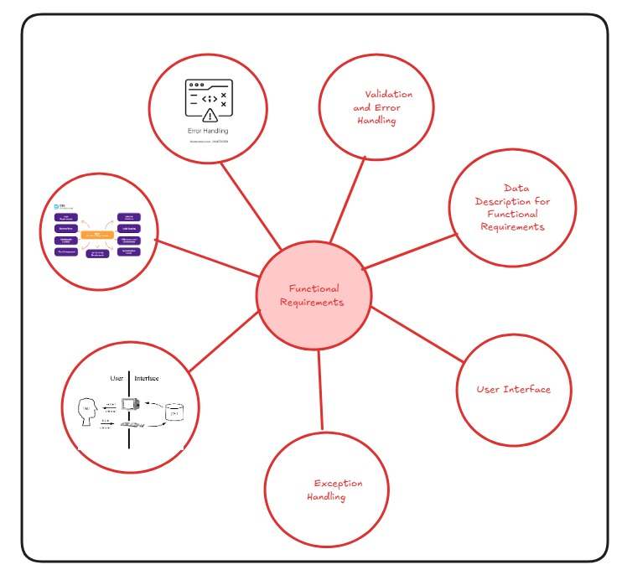
Validation and Error Handling
• Users informed of all validation failures (e.g., invalid login, wrong temperature values) with clear error messages.
· System-generated data errors (e.g., incorrect sensor readings) → process aborted and error logged.
· User-input errors (e.g., invalid device name, wrong schedule time) → user allowed to correct and retry.
Exception Handling
• Exceptions include violation of preconditions (e.g., device not connected) or business rules (e.g., power threshold exceeded).
• Functional requirements describe only the normal processing flow (e.g., turning on lights, setting thermostat schedules), not exceptional event flows.
• Data Description for Functional Requirements
For each functional requirement, the following data shall be specified:
- Unique name (e.g., DeviceID, RoomName, TemperatureSetting)
- Input/Output type (user-provided, system-generated, or output result)
- Data format (alphanumeric, numeric, Boolean, etc.)
- Validation rules (e.g., password ≥ 8, temperature 16°C–30°C, light 0–100%)
- Multiplicity (occurs once – user login, or multiple times – controlling devices)
- Optionality (mandatory – UserID, or optional – device nickname)
- User Interface
The graphical design of the user interface (UI) is not in scope for this document. However, functional requirements shall clearly specify the inputs, outputs, and validations expected from the system interface.

3.1 HACS Authentication System
The system shall support for logging information’s

Function Name: HACS Login

3.1.1 Trigger
- A person wants to login to the HACS system for establishing connection

3.1.2 Pre-Conditions
- User needs a valid user name and password to logon to the HACS system.

3.1.3 Post-Conditions
- A session is established for the authenticated user

3.1.4 Business Rules Applicable
- Logging can be made at anytime
- Single accounts can be created

3.1.5 Data Manipulated
Type | Name | Format | Validation Rules
Input | Start time | hh:mm | Between 08:00 & 20:00
Input | Duration | Numeric | 1, 2 or 3
Input | Login ID | Alpha  Numeric | Max 8 character
System | Password | Alpha-numeric | Max 8 characters
System | System date | dd/mm/yyyy
System | System time | Hh:mm
Table 3.0 Inputs required for HACS_Register

3.1.6 Normal Processing Procedure
- User enters to HACS system
- User enters user id and password
- System validates login information
- User establishes the connection between remote system and user
- System displays appliance menu to the users
- User selects one of the appliance from the menu
- User start operating the appliance
- System exits or cancel while operation is completed

3.1.7 Variations
- If user is idle, system displays “Sorry, user is idle for long time”.
- System prompts user to quit .

3.1.8 Exceptions
Exception | Error Message (Displayed/Generated/Logged)
Entering wrong username and password | Re-enter your user name and password.
Creating password with undefined symbols | Type your password correctly

3.2 HACS Appliance Controller list
The system shall support in displaying the appliance menu

Function Name: HACS_ Appliances

3.2.1 Trigger
- A user successfully logs into the HACS system and requests to view the appliance menu.

3.2.2 Pre-Condition
- User must have an authenticated session.
- At least one appliance must be registered in the system database.

3.2.3 Post-Condition
- The system displays a list of appliances available for control.
- The user can select an appliance for further action (turn ON/OFF, schedule, monitor, etc.).

3.2.4 Business Rules Applicable
- Appliances must be uniquely identifiable (e.g., Appliance ID).
- Only appliances registered under the user’s account shall be displayed.
- Inactive appliances (disconnected from the network) shall be shown as unavailable.

3.2.5 Data Manipulated
Type | Name | Format | Validation Rules
Input | User Request | Command
  Must be valid selection (View Appliances)
System | Appliance ID | Alphanumeric | Unique, max 10 characters
System | Appliance Name | Text | Max 30 characters
System | Status | Text (ON/OFF) | Must be either "ON" or "OFF"
System | Location | Text | Optional, max 20 characters
Output | Appliance List | Structured list | Must contain all valid appliances under the user
Table 5.0 Inputs required for HACS_ Appliance

3.2.6 Normal Processing Procedure
- User selects “View Appliances” option.
- System fetches the list of appliances from the database.
- System validates appliance records (active/registered).
- System displays the appliance list with details such as ID, Name, Status, and Location.
- User selects an appliance to control.

3.2.7 Variations
- If no appliances are registered, system displays: “No appliances found.”
- If an appliance is offline, it is shown as Unavailable.

3.2.8 Reports Generated
- Appliance usage report (optional – generated weekly/monthly).
- Appliance list summary (current session).

3.2.9 Exceptions
Exception | Error Message (Displayed/Generated/Logged)
No appliances registered | “No appliances available in your account.”
Database connection error
  “Unable to fetch appliance list. Please try again later.”
Invalid user session | “Session expired. Please login again.”
Table 6.0 Exceptions during Chat_Private

3.3 HACS Appliance Control
The system shall support controlling appliances (e.g., switching ON/OFF, scheduling, or adjusting settings).
Function Name: HACS_ApplianceControl
3.3.1 Trigger
- A user selects a specific appliance from the appliance list to perform an action (ON/OFF, schedule, adjust).
3.3.2 Pre-Condition
- User must be authenticated and logged in.
- Appliance must exist in the user’s account.
- Appliance must be connected and in an active state.
3.3.3 Post-Condition
- The system successfully executes the selected control action.
- Appliance status is updated in the system database.
- Confirmation message is displayed to the user.
3.3.4 Business Rules Applicable
- Only authorized users can control appliances.
- The system must ensure one valid command is executed at a time.
- Commands cannot conflict (e.g., scheduling “Turn ON” and “Turn OFF” at the same exact time).
3.3.5 Data Manipulated
Type | Name | Format | Validation Rules
Input | Appliance  ID | Alphanumeric | Must exist in system, max 10 characters
Input | Command | Text | Must be valid (ON/OFF/SCHEDULE)
Input | Schedule Time | Time (HH:MM) | Optional, must be in 24-hour format
System | Appliance Status | Text | Must be updated to "ON" or "OFF"
Output | Confirmation Msg | Text | Displayed after successful action
Table 7.0 Inputs required for HACS_ApplianceControl
3.3.6 Normal Processing Procedure
- User selects an appliance and chooses a control action (ON/OFF or schedule).
- System validates the command and appliance status.
- If valid, the command is sent to the appliance.
- Appliance responds with success/failure.
- System updates the database with the new status.
- System displays a confirmation message to the user.
3.3.7 Variations
- If scheduling is selected, the system stores the schedule and executes the action at the specified time.
- If the appliance is already in the requested state (e.g., ON), system informs: “Appliance is already ON.”
3.3.8 Reports Generated
- Action logs (e.g., Appliance X turned ON at 7:30 PM).
- Scheduled action summary report (optional).
3.3.9 Exceptions
Exception | Error Message (Displayed/Generated/Logged)
Appliance not found | “Selected appliance does not exist.”
Invalid command
  “Invalid control command. Please try again.”
 | “Unable to perform action. Appliance is offline.”
  Appliance offline
Schedule conflict | “Schedule overlaps with another action.”
Database error | “System error while updating appliance status.”
Table 8.0 Exceptions during HACS_ApplianceControl

4. User Interface Requirements
The HACS GUI shall be simple, consistent, and accessible for homeowners, guests, and administrators, emphasizing clarity and minimal learning effort.
4.1 Look and Feel Requirements
Each screen will show the system name, slogan, and footer with date/time. A consistent color scheme will be used, with clear status indicators (Green = ON, Red = OFF, Grey = Inactive). Navigation bars with icons and labels, uniform buttons, sans-serif fonts (min. 12pt), and highlighted critical functions (e.g., Red for Emergency Shutdown) will ensure clarity and readability.
4.2 Usability Requirements
The GUI will support non-technical users with menu-driven, icon-based navigation, accessible within three clicks. New users should complete basic tasks (e.g., ON/OFF appliances) within two minutes. Clear error messages, immediate feedback, large buttons, spacing, and optional tooltips will ensure easy and error-free interaction

5. Non-Functional requirements
This section defines the quality attributes and constraints that the Home Automation Control System (HACS) must satisfy to ensure smooth operation, scalability, and user satisfaction. 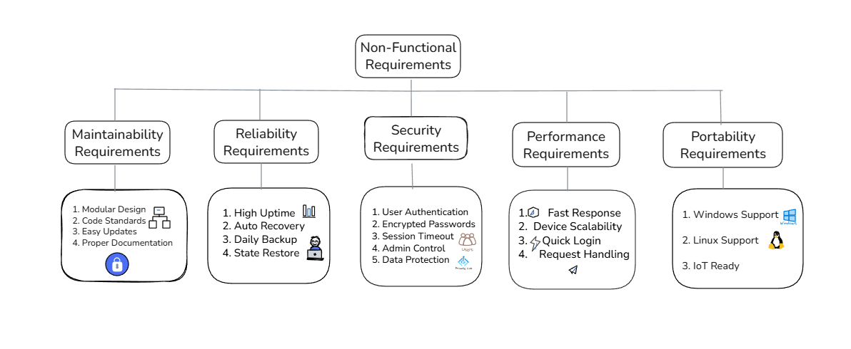

5.1 Performance requirements
- The system shall respond to user commands (e.g., turning appliances ON/OFF) within 2 seconds under normal operating conditions.
- The system shall support at least 50 concurrent devices without performance degradation.
- Login authentication shall be completed within 3 seconds.
- The system shall handle up to 100 user requests per minute without failure.

5.2 Reliability requirements
• The system shall maintain 99% uptime during normal operation. The system shall recover from minor failures (e.g., appliance disconnection) automatically within 10 seconds.
• All critical data (e.g., user profiles, appliance states) shall be backed up daily. In case of unexpected shutdown, the system shall restore to the last saved state upon restart.

5.3 Security requirements
• User authentication shall be enforced via username and password.
• Passwords shall be stored using encryption techniques.
• The system shall automatically lock a session after 5 minutes of inactivity.
• Only authorized admin users shall have access to add/remove appliances or modify system settings.
• Sensitive data (e.g., login details, device states) shall be protected from unauthorized access using role-based access control (RBAC).

5.4 Maintainability requirements
• The system architecture shall be modular, allowing updates to individual components (e.g., device drivers) without affecting the entire system.
• The source code shall follow Java coding standards to ensure readability and maintainability.
• System updates (e.g., bug fixes, new features) shall be deployable with minimal downtime (<30 minutes).
• Documentation shall be maintained and updated alongside system changes.

5.5 Other non-functional requirements …
• The system shall have a user-friendly interface accessible to both technical and non-technical users.
• The system shall support cross-platform compatibility for access via desktop and mobile devices.
• The system shall be designed to minimize power consumption of connected devices by optimizing communication protocols.

5.6 Portability Requirements
• The system shall run on Windows OS with Java Virtual Machine (version 1.3.1 or above).
• The system shall be portable to Linux-based servers with minimal configuration changes.
• The system shall support future upgrades to IoT-enabled devices without major architectural redesign.

6. Operating Environment
The system specified shall operate on the hardware, software requirements outlined in this section.

6.1 Hardware
The system is expected to have the following minimum configuration:
• Minimum Dual Core 2.0 GHz processor or above.
• 4 GB RAM minimum.
• 500 MB free disk space.
• HD Monitor (1024x768 resolution or above).

6.2 Software
• Windows 10 / 11 or Linux (Ubuntu 20.04 or above).
• Java Virtual Machine (JDK 11 or above).

6.3 Printer
The printer must be compatible with the computer system and must be capable of printing text files.

6.4 External Data Storage
• Backup and archival supported on USB drive, external HDD/SSD, or cloud storage (Google Drive / OneDrive / AWS S3).
• The system administrator must ensure secure backup and retrieval of appliance data.

7. Acceptance Criteria
The system must be able to:
- Secure login/logout with valid credentials.
- Display connected appliances with status (ON/OFF).
- Switch appliances ON/OFF remotely via the interface.
- Validate user inputs and show error/success messages.
- Generate usage reports (e.g., appliance history).
- Maintain response time < 3 seconds for any request.
- Provide backup and recovery of stored data.
- Run correctly on defined environment (Windows / JVM).
- Maintain ≥95% uptime during normal operation.

References

- Allen, R., “Software Development 2 Lecture Notes”, 2003

- “Software Engineering/Introduction to Software Engineering Course Notes”, Semester 1 2003
(Include references)
Glossary
- HACS (Home Appliance Control System): Software to remotely control & monitor appliances.
- Appliance: Any electrical/electronic device (e.g., fan, light, AC) controllable via HACS.
- Authentication: Verify user identity before access.
- Authorization: Grant/restrict privileges to authenticated users.
- Session: Interaction from login to logout.
- JVM (Java Virtual Machine): Runs Java apps, ensures platform independence.
- Trigger: Event that starts a function (e.g., Login click).
- Pre-Condition: Must be true before execution (e.g., valid credentials).
- Post-Condition: System state after execution.
- Usecase Diagram:
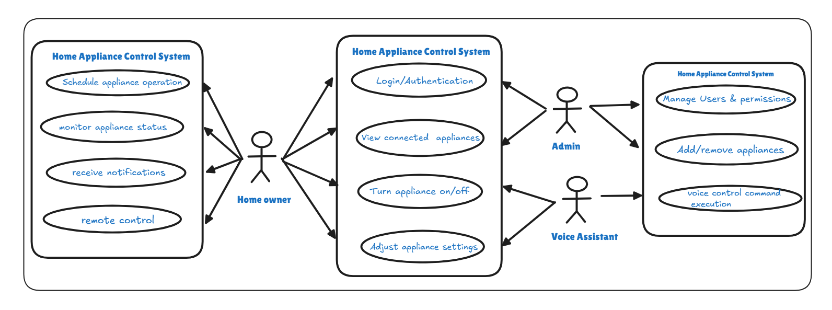

Context Diagram:

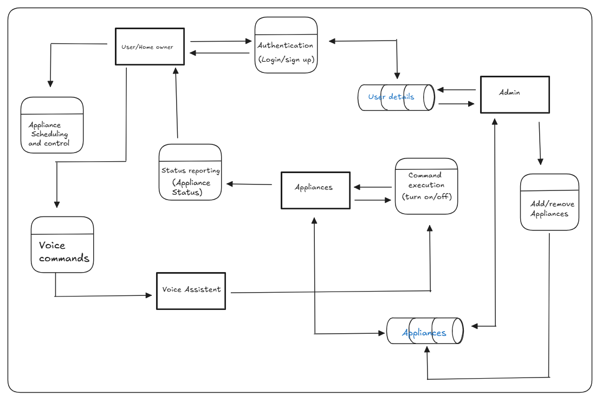

Purpose of Appendices
Appendices include supporting material helpful for understanding requirements but not essential to the main document.
- The first two appendices provide sample input/output data, user scenarios, or reference diagrams.
- The remaining appendices are for educational purposes, added to demonstrate methodology and offer learning resources (not typically part of a professional SRS).
Appendix A: External Context Model

Description:

The external context model defines the interaction between the HACS system and external entities such as users, administrators, appliances, and external services.
Entities:
Remote User: Initiates appliance control requests via mobile or web interface.
Administrator: Manages appliances and users.
Appliances: Microwave, Sprinkler, Pet Feeder, etc.
External Services (AI Integration): Weather APIs for adaptive scheduling, Cloud AI for voice command processing.

Appendix B: Internal Context Model
Description:
The internal context model represents internal components and their interactions.
Components:
Authentication Module: Verifies user credentials.
Session Manager: Maintains valid communication sessions.
Appliance Controller: Executes ON/OFF and schedule commands.
AI Module: Predictive control, energy optimization, voice command interpretation.
Database: Stores user info, appliance states, logs.
AI Real-world Link: AI module works like Google Home’s smart routines for automation.

Appendix C: Use Case Analysis Notes
Primary Use Cases
- 1. Login and Session Management – Validate users and establish sessions.
- 2. View Appliance Menu – Display available appliances.
- 3. Control Appliance – ON/OFF, schedule, or adjust settings.
- 4. AI Suggestions (Extended Use Case) – Suggest optimal schedules based on past usage.
AI Example:
When a user logs in, the system may suggest “Start microwave for breakfast?” based on previous behavior.

Appendix D: Development Process
You should describe all the various tasks that you have conducted as well as the various techniques that you have used in the development of this document. You need to describe all information that has been used as inputs for each of the tasks as well as the outputs produced.
Tasks Undertaken
Task Name | Description | Technique(s) Used
Requirement Elicitation | Collected system requirements from assignment brief Interviews, Document Review. | https://docs.google.com/forms/d/e/1FAIp  QLSfogSQ_eqUITy  cTzqr7msrEPk3frHbbO9--CFHvlcsnjckSvg/  viewform?usp=header  (GOOGLE FORM LINK)
Use Case Modeling | Defined system interactions and flows | UML Use Case Diagram
AI Feature Identification | Analyzed opportunities for AI in HACS | Brainstorming, Research

Table 51.0 Tasks undertaken in the development of this document

Appendix D: Task Log and Outputs
Table D1.0 Tasks Undertaken
Task Name | Description | Technique(s) Used | Notes
Requirements Gathering | Identified user needs for monitoring and controlling appliances remotely. | Interviews, brainstorming, document analysis | Helped in defining functional requirements.
System Scope Definition | Outlined system boundaries, users, and appliances covered. | Context diagrams, use case identification | Provided foundation for requirements specification.
Functional Requirements Specification | Documented actions like ON/OFF, scheduling, and adding appliances. | Use case modeling, user stories | Captured all user and system functions.
Non-Functional Requirements Specification | Defined security, reliability, and scalability constraints. | Quality attribute checklists, expert review | Ensured system performance and usability.
Interface Design | Designed GUI structure and usability features. | Wire framing, prototyping, usability heuristics | Ensured clarity, consistency, and accessibility.
Table 52.0 Sections affected by the various tasks.

Table D2.0 Sections Affected by Tasks
Task Name | Outputs | Section(s)
Requirements Gathering | User Needs, Appliance Scenarios | 1.2 Scope, 2.1 Introduction
System Scope Definition | System Boundaries, Actors | 1.4 Constraints, 1.8 Assumptions
Functional Requirements Specification | Use Cases, Functional List | 2.3 Functional Requirements, 7.0 Use Cases
Non-Functional Requirements Specification | Security, Reliability, Scalability | 5.3 – 5.6 Non-Functional Requirements
Interface Design | GUI Requirements, Usability Criteria | 4.0 User Interface Requirements

Appendix E: Contributions
Table E1.0 Document Contributions
Contributor Name Sections Worked On

- DHARSHINI - Introduction, Product Overview
H.RAJESHWARI - Functional Requirements, UI Requirements
G.SHANGARA VADIVEL - Non-Functional Requirements, Operating Environment
S. ARIVU SELVAN - Appendices A, B, C,D, E.
R.J. RAJIVARTHINI - Appendices D, E, F, G,Non-Functional Requirements

Appendix F: Meeting Agendas/Minutes
Table F1.0 Meeting Dates/Times
ID | Meeting Date/Time | Agenda
1 | 10/08/2025, 2:00 PM – 3:00 PM | Requirement Gathering & Assigning Sections
2 | 15/08/2025, 4:00 PM – 5:00 PM | Review of Functional and Non-Functional Sections
Agenda & Minutes (Sample for Meeting 1):
Agenda: Finalize project scope, identify key appliances, assign roles.
Minutes: Agreed on HACS scope (microwave, sprinkler, AC, pet feeder, security system). Assigned tasks: Student A (template), Student B (requirements), Student C (UI), Student D (review).

Appendix G: Problem Investigation Reports

Purpose:

To document problems encountered during requirements elicitation and SRS preparation, along with their resolutions.

Problem ID Description Resolution

P1 | Ambiguity in appliance control operations requirements | Discussed with team and clarified actions
P2 | Missing non-functional requirement details | Researched IEEE SRS standards and updated
P3 | Confusion over context model format | Referred to IEEE examples and created diagrams

